SiD for Dummies

**Opening SiD**

* Drag the SiD files into the MATLAB folder on your desktop
* Open MATLAB
* Click the MATLAB folder on the left hand side and find the latest version of SiD
* Right click the folder 🡪 add to path 🡪 selected folders and subfolders
* Type ‘savepath’ in the command window
* Then type sidRun(“help”) to open SiD

**Making a jobset**

* **Image selection:**
  + Click ‘New run’
  + Select directory (the folder where the images you want to analyse are on Ceres)
  + In the window below select the images (.dv files) you want to analyse **for this condition** eg. Ctrl or siRNA etc. **You need to make a separate jobset for each condition.**
  + Click ‘Add & crop’
  + Click Add ROI
  + Draw the square around the cell, double click and click Finish. Repeat for each image
  + Delete any images you don’t want by clicking Delete. You can also view them by clicking View ROI
* **Options:**
  + Select the channel you want spots detected in eg. CREST
  + Select the channels you want intensities measured eg. Other antibodies
  + Leave the spot detection variables as they are
* **Final checks:**
  + Create a filename eg. RPE1Ctrl_det2_meas34
  + Validate metadata for each image (Z slices should change for each image)
  + Click Save jobset
* **Running the jobsets**
  + This is where the computer finds the spots and measures intensities.
  + Load the jobset you want to run
  + You can create multiple jobsets and run them at the same time using Multi-job run
  + Click Run
  + This should take 3-5 minutes for 10 images

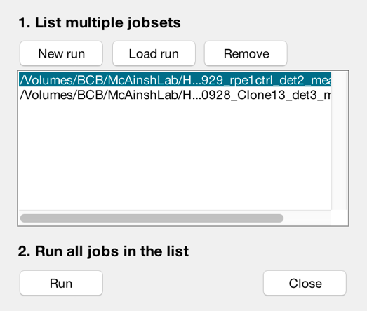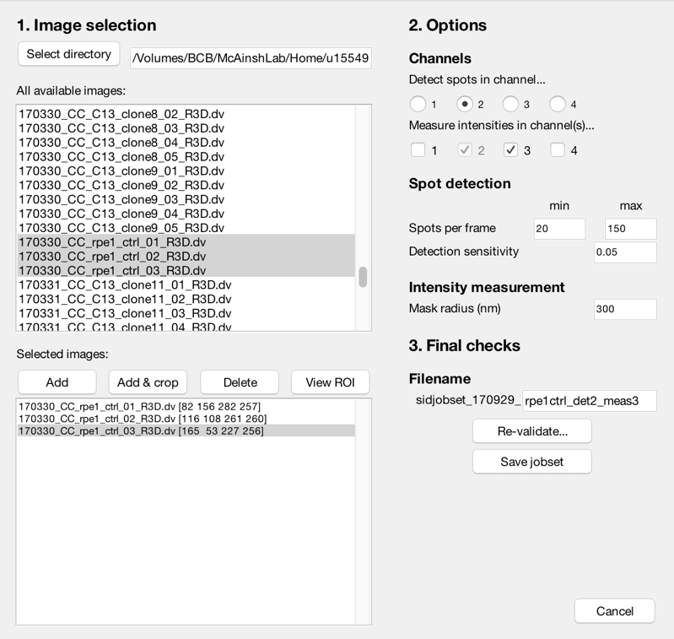

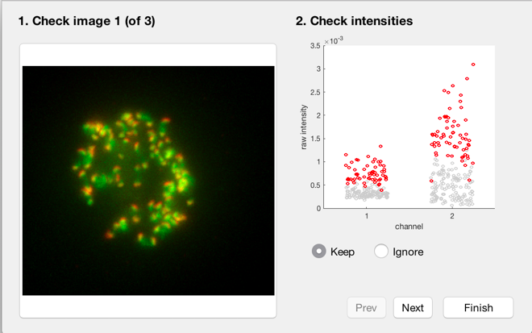**Manually checking data:**

* **Cell filtering:**
  + Shows you where the data from each individual cell is in relation to the other cells in the dataset. You can choose to keep the cell, or ignore it.

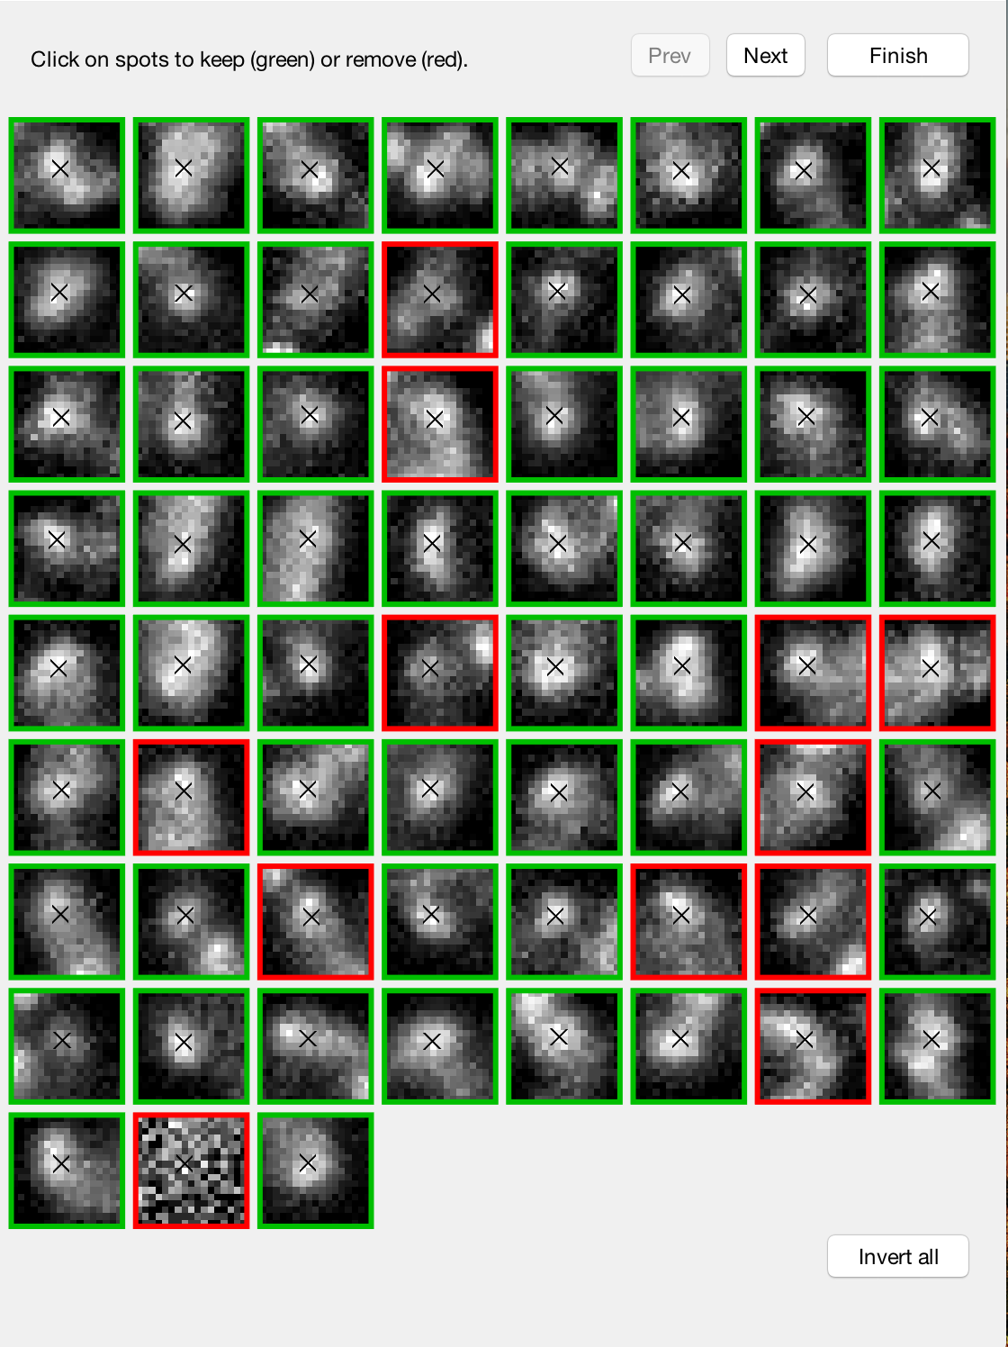

* **Spot filtering:**
  + Screen the spots detected by SiD
  + Click the boxes to toggle between green and red. Red removes this spot from the data.
  + Click invert all to change all boxes to red

**Analysis of results**

* **Conditions:**
  + Add the number of conditions you want eg. Ctrl, clone 1, clone 2 etc and name them.
  + Check the box to normalise to the control condition (if necessary)
  + Click “Find jobset(s)” and open the folder of images analysed. Select the jobset file for that condition.
  + Repeat for other conditions
* **Options:**
  + Select control (CREST) channel
  + Select channels to analyse
  + Name the channels eg. Crest, Bub1
  + Choose your plot style
  + Select the box ‘Leave figures open afterwards’
* **Saving and running:**
  + Select a save directory (can be any folder on your computer)
  + Create a filename eg. Sidanalysis_170929_Ctrl_Clone8_crest_bub1
  + Click ‘Run’

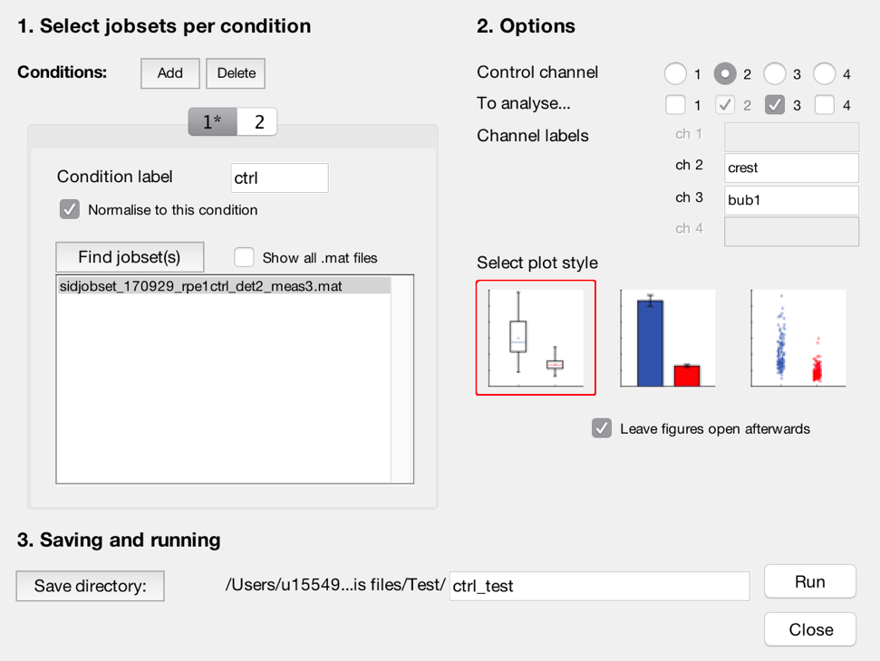

SiD creates 3 graphs:

* Spot normalised: Every spot normalised to its respective CREST value
* Cell normalised: Every sport normalised to an average CREST value for the whole cell
* Background corrected: used to check if CREST differs between conditions

It also outputs .csv files to be used in other programmes eg. R, Excel.